Near Miss Reporting Form

Completed By: Position: | Date:
Job / Process / Location / Persons involved :

Description of Near Miss:

Rating of Risk (potential risk) | 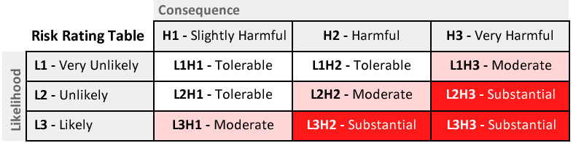
(Rate the near-miss based on potential consequence and probability of recurrence)
Cause of Near-Miss :

Any action required to prevent recurrence* :

*If corrective action is required this should be logged on issues register.

